OFFICE OF THE
HIGH REPRESENTATIVE
Emerika Bluma 1, 71000 Sarajevo
Tel: 387 33 283500 Fax: 387 33 283501

15 May 2003

Mr. Obren Petrovic
Acting Mayor
Municipality of Doboj
Republika Srpska
Bosnia and Herzegovina

Dear Mr. Petrovic,

On 10 August 2001, OHR initiated a review of the 4 December 2000 Kotorsko waiver from the High Representative’s Decision of 27 April 2000 that banned the reallocation of state-owned property, including former socially-owned property, after receiving information seriously calling into question the accuracy of the information submitted by your municipality in its application for that waiver.

That review confirmed that:

- The Public Attorney’s Office, as confirmed by the 16 August 2001 letter of Deputy Public Attorney Cvijanovic, did not verify that the proposed allocation complied with all relevant local laws and regulations;
- The registered allocation right holder of parcel 2454/9 is “Enterijer factory” and not “Bosnakop” as alleged in the Doboj waiver application, representing a material misstatement of fact;
- The transfer of land between “Enterijer factory” to the municipality was conditioned upon subsequent reallocation of the plots to employees of the factory, a criteria for beneficiary selection that would violate the condition of vulnerability under which OHR granted the waiver;
- 9 plots were registered as privately owned thereby bringing into question the ownership status of significant portions of the reallocated land and, further, making certification of legal compliance by the public attorney inappropriate;
- The application failed to certify that the proposed reallocation of the parcels 2452, 2453/1, 2545, and 2453/9, where its use for non-agricultural purposes is restricted by the RS Law on Agricultural Land, would be in full compliance with the law;
- That serious discrepancies existed regarding the identity of beneficiaries and their status as vulnerable persons.

Considering these issues related to the 23 June 2000 Doboj waiver, which suggests that the land allocation in question was not in accordance with the applicable laws and regulations, and considering further the ongoing dispute regarding ownership of the land, OHR suspended the Kotorsko waiver on 30 August 2001.

Moreover, following the suspension of the waiver, several lawsuits before local courts and the Human Rights Chamber were filed by a group of returnees alleging ownership on the land encompassed by the waiver, which remain unresolved. These lawsuits have highlighted the questions raised in the suspension procedure.

On 17 June 2002, the Basic Court in Doboj issued the Decision No: P-244/02, ruling:
- that the Contract on the Out of Court Settlement in the procedure of expropriation of 20 March 2000, concluded between the Executive Board of Doboj Municipality and the Agricultural Co-operative “Bosnakop” Doboj, is null and void;
- that the defendants are ordered to return the property to the complainants; and
- that the defendants are obliged to pay procedural expenses of the law-suit

Following an appeal filed by the defendants, the District Court in Doboj issued the Decision No: Gz- 499/02 of 5 August 2002, which rejected the ruling under item 1 of the Basic Court’s Decision and revoked the orders under items 2 and 3, and remanded the case for a new trial. On 24 September 2002, the Basic Court issued Decision no: P-533/02, again annulling the referenced contract. This ruling was again overturned and remanded for retrial by the District’s Court Decision of 21 November 2003 no: Gz-671/02. Currently, the case is before the Doboj Basic Court.
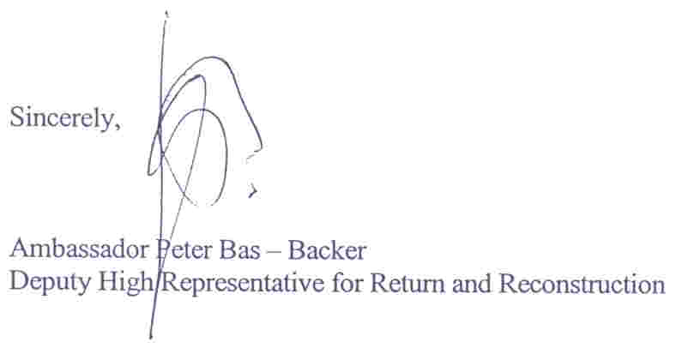
Considering the issues raised in the unresolved legal dispute bring into serious question the accuracy of the information upon which OHR based its 4 December 2000 waiver from the High Representative’s Decision for the land allocation in Kotorsko, the aforementioned waiver is herewith cancelled.

Cc: Ambassador Mr. Gerhard Enver Schröembgens
Senior Deputy High Representative

Mr. Bozo Cvijanovic
Deputy Republic Public Attorney of Republika Srpska

Mr. James Bigus
Head of the OHR Tuzla

OHR Doboj

